For pretrained weights model

Resnet has

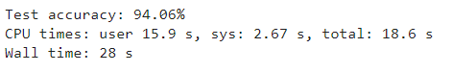

Alexnet has

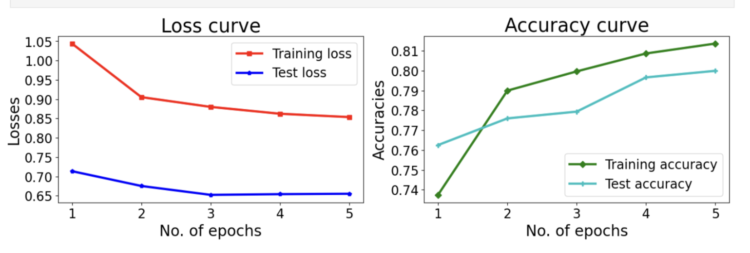

About 80% Accuracy So Clearly Resnet is better than AlexNet

On implementing AlexNet from Scratch the

On unregularized Case and learning rate=0.005 the performance is

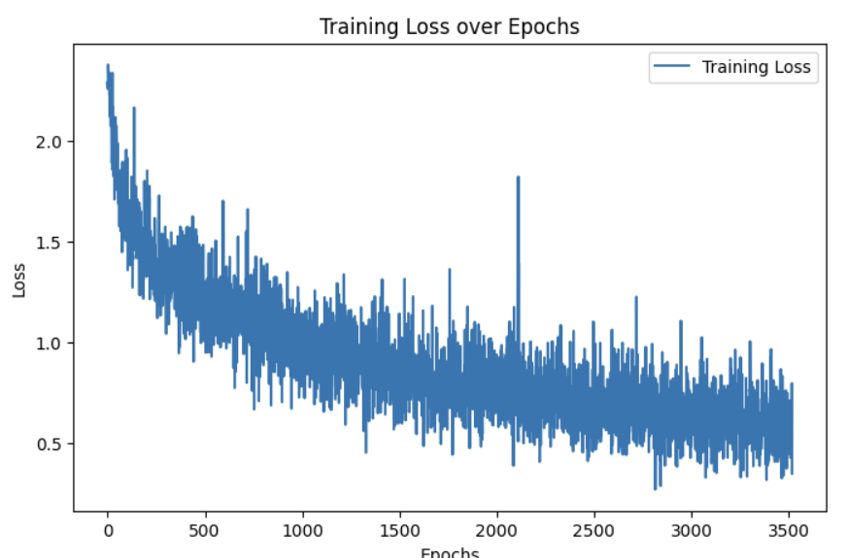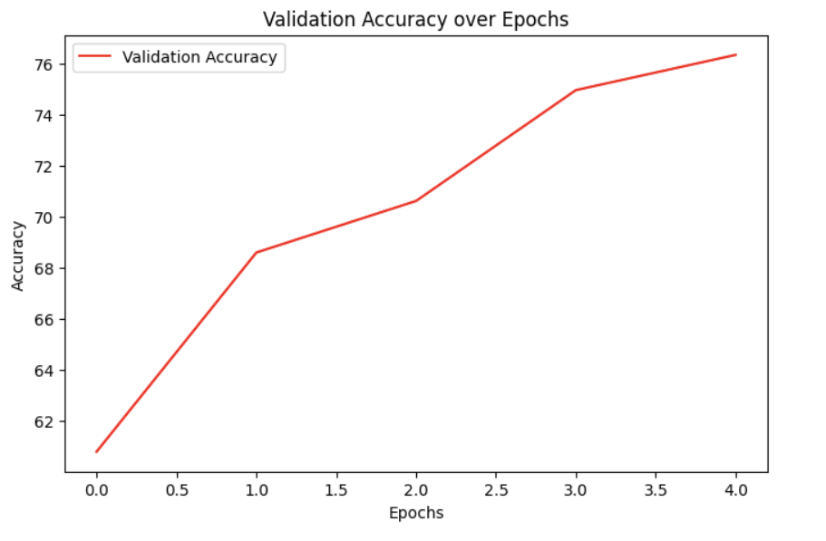



On regularized with weight_decay=0.001 and learning rate=0.005 it is

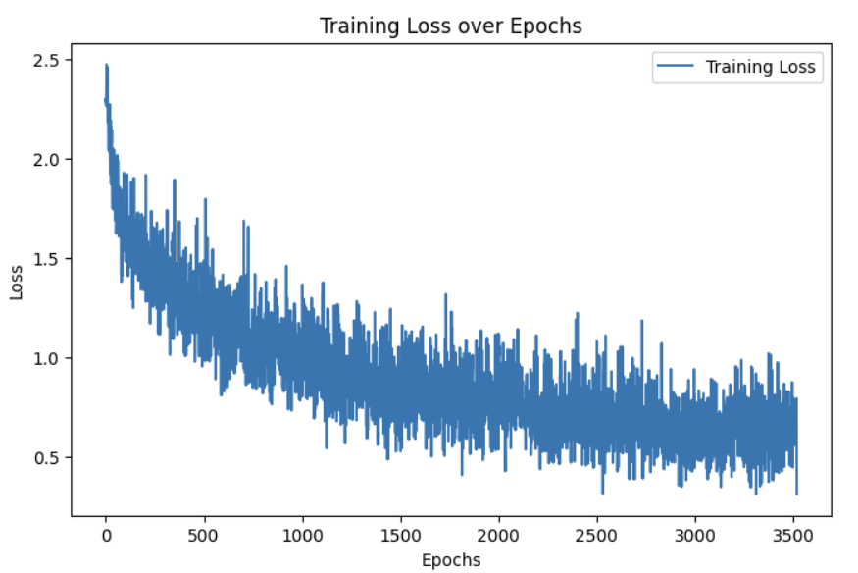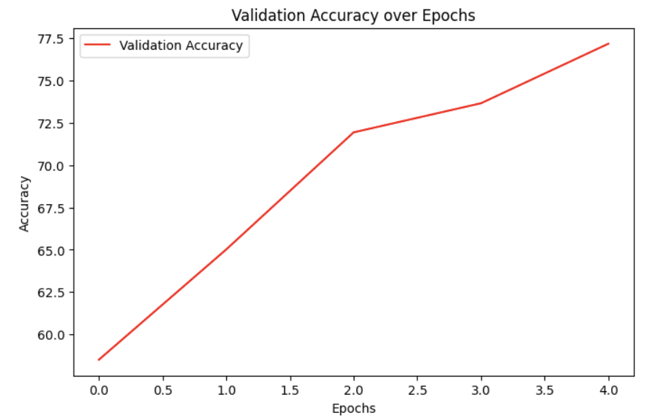



On regularized with weight_decay=0.001 and learning rate=0.010 it is

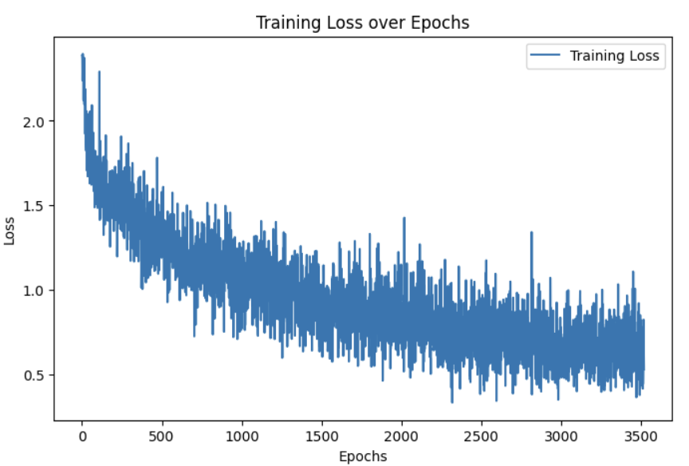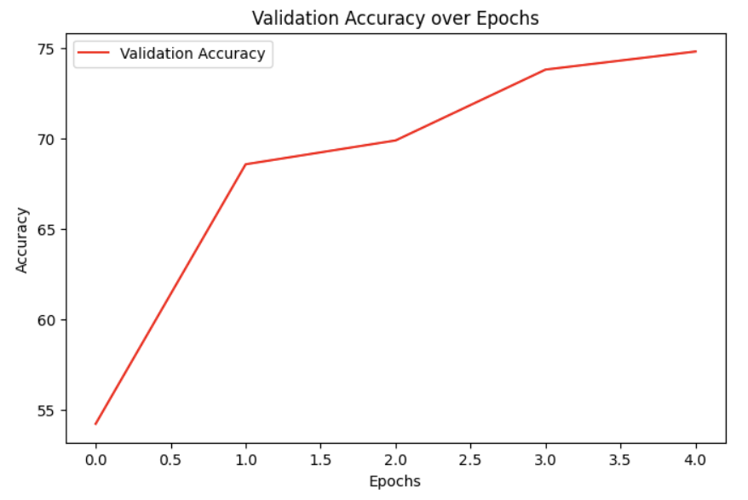



So We can see increasing the learning rate decreased the accuracy of our model and Regularization increases the Accuracy of our Model

Now for Resnet from Scratch

On implementing AlexNet from Scratch the

On unregularized Case and learning rate=0.01 the performance is

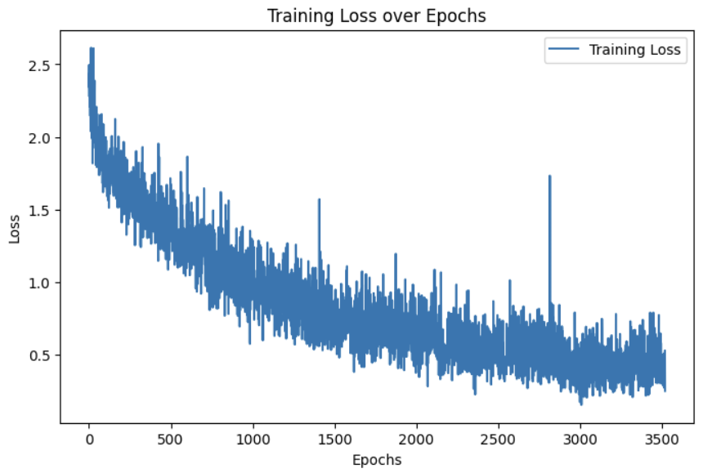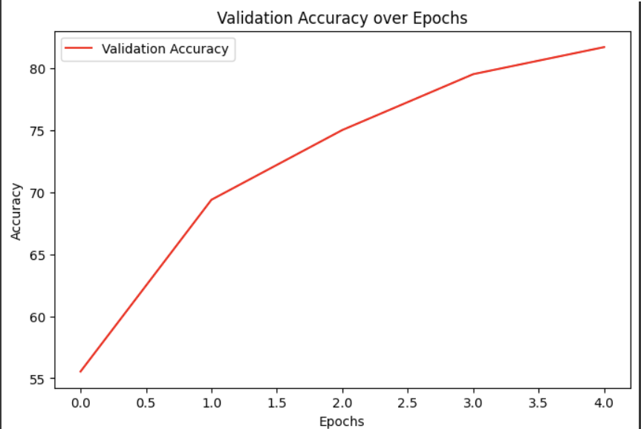



On regularized with weight_decay=0.001 and learning rate=0.01 it is

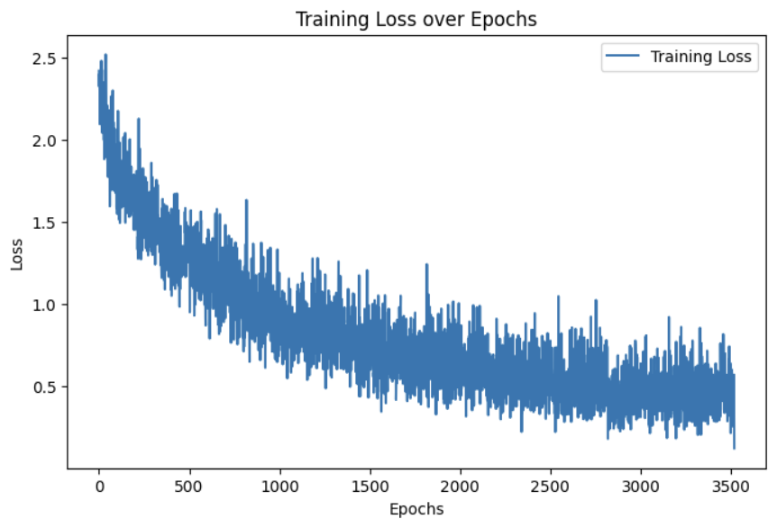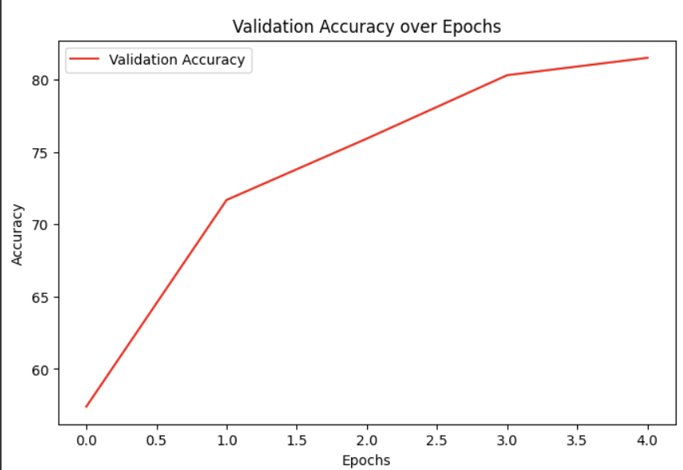



On regularized with weight_decay=0.001 and learning rate=0.02 it is

